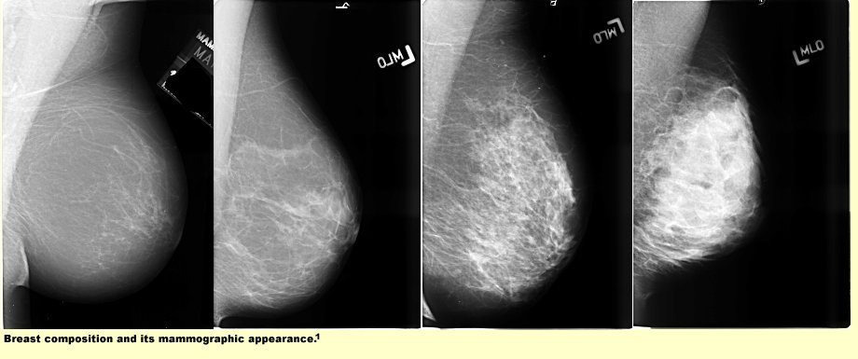

The figures above are illustrations of the four BI-RADS grades of breast tissue density (from left to right) least dense through extremely dense.

