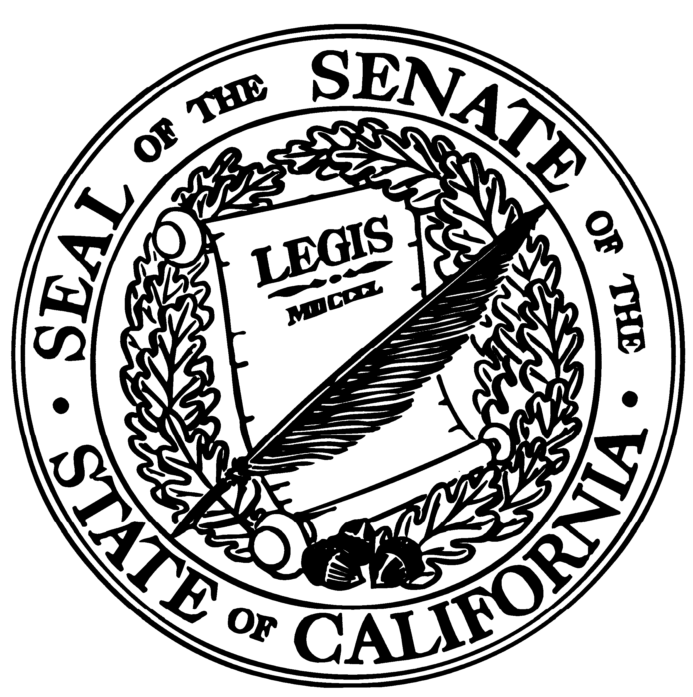
DISTRICT OFFICE
160 Town & Country Village
Palo Alto, CA 94301
(650) 688-6384
Fax (650) 688-6370

SATELLITE OFFICE
701 Ocean Street, Room 318A
Santa Cruz, CA 95060
(831) 425-0401
Fax (831) 425-5124

STATE CAPITOL
SACRAMENTO, CA 95814
(916) 651-4011
Fax (916) 323-4529

E-MAIL
Senator.Simitian@sen.ca.gov

WEBSITE
http://www.sen.ca.gov/simitian

California State Senate

SENATOR
S. JOSEPH SIMITIAN
ELEVENTH SENATE DISTRICT

Fact Sheet: Senate Bill 1475 (Simitian)
Cell phone use

SB 1475 is designed to improve compliance with existing distracted driving laws. Specifically, the bill would:

- Increase the base fines for violation of the hands free cell phone and texting-while-driving laws from $20 to $50 for a first offense, and from $50 to $100 for subsequent offenses;

- Make a violation of the hands free cell phone law, the texting law, or the teen safety law a driver’s license “point”;

- Apply these distracted driving laws to bicyclists at a lower total fine level of $20 for a first offense, and $50 for each subsequent offense;

- Establish and fund a cell phone related distracted driving education program in the Office of Traffic Safety (OTS); and,

- Allow the state to qualify for anticipated federal funding on cell phone related distracted driving.

NEED FOR THE BILL:

Compliance with the existing laws has been good, but it could be better. CHP data on the hands free law indicates a roughly 20 percent reduction in both fatalities and collisions, as well as a nearly 50 percent reduction in distracted driving accidents where the identified distraction was a handheld cell phone. Establishing a public awareness program and enhancing penalties will improve compliance and provide a more meaningful deterrent.

Staff Contact: Ryan Ojakian; (916) 651-4011 or ryan.ojakian@sen.ca.gov
Updated – 13may10

